Appendix № 1
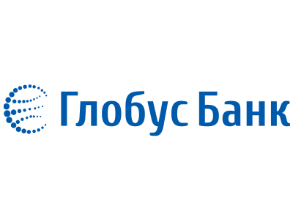
APPROVED
By the decision of the Tariff Committee
JSC "CB "GLOBUS»
Protocol No. 43 dated June 11, 2026
Chairman of the Management Board __signature___ Mamedov S.G.
Tariffs for services of the "GLOBUS" international money transfer system
1. Domestic transfers between individuals (excluding VAT)
Transfer amount | Transfer currency | Tariff for sending a transfer | Tariff for paying out a transfer
Any amount | UAH | 0.5%, min. 10 UAH | No fee is charged
2. Domestic transfers from a legal entity to individuals (excluding VAT)
Transfer amount | Transfer currency | Tariff for sending the transfer | Tariff for paying out the transfer
Any amount (cash payout) | UAH | from 0.3%, min. 10 UAH | No fee is charged
Up to 30,000.00 UAH (payout to card) | UAH | 1%, min. 10 UAH | No fee is charged
3. Domestic transfers between individuals with instant payout to a card of any Ukrainian bank
Transfer amount | Transfer currency | Tariff for sending the transfer
Up to 30,000.00 UAH | UAH | 1%, min. 10 UAH
When calculating the commission amount according to the Tariffs for the services of the "GLOBUS" International money transfer system for domestic transfers, the following rounding rules apply:
- an amount ending from 1 to 24 kopecks is rounded down to the nearest amount ending in 00 kopecks;
- an amount ending from 25 to 49 kopecks is rounded up to 50 kopecks;
- an amount ending from 51 to 74 kopecks is rounded down to 50 kopecks;
- an amount ending from 75 to 99 kopecks is rounded up to the nearest amount ending in 00 kopecks.
4. Cross-border transfers between individuals
Transfer direction | Transfer currency | Tariff for sending the transfer | Tariff for paying out the transfer
Sending a transfer from European countries to Ukraine via PAYSERA | EUR / USD | 1.8% | No fee is charged

